NAN-E BADAMI. PERSIAN ALMOND COOKIES

Posted on [March 20, 2014](http://rhubarbandrosewater.wordpress.com/2014/03/20/nan-e-badami-persian-almond-cookies/) by [rhubarbandrosewater](http://rhubarbandrosewater.wordpress.com/author/rhubarbandrosewater/" \o "View all posts by rhubarbandrosewater)

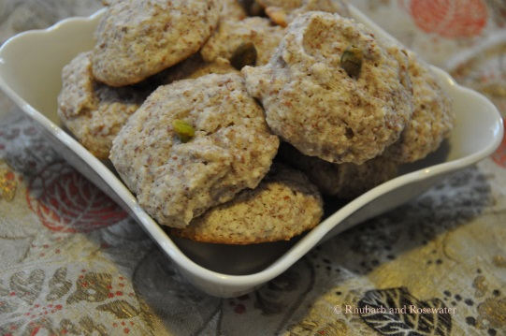Ingredients:

1 pound almond flour  
5 egg whites  
1 1/2 cups confectioners’ sugar  
zest of 1 orange  
2 tablespoons rosewater  
pistachios for decoration

1.) Beat the egg whites in a mixing bowl. Mix in the sugar and the almond flour.

2.) Add orange peel and rosewater. Mix gently. Preheat the oven to 350˚F.

3.) Scoop a tablespoon of dough for each cookie on a lined cookie sheet. Garnish each cookie with a pistachio.

4.) Bake in the center of the oven for 15 to 20 minutes until light gold.

5.) Let them cool off for a few minutes and then remove them from the cookie sheet.